**Nutrient Excretion Preliminary Results**

Method Detection Limits (MDL):

Phosphorus: 1.58 ug/L

Nitrogen: 1.34 ug/L

For the purpose of statistical analysis, the results below the MDL were given a value of ½ the detection limit. (0.79 ug/L for P, 0.67 ug/L for N). This was applied to 3 phosphorus samples and 10 ammonia samples.

*There are still some nitrogen excretion rates that are negative since the blank (background concentration) was higher than the samples that had organisms in them. This applied to 16 data points. I ended up log transforming the data to meet assumptions of linear mixed models but it did remove these data points. Is there a better way of handling these data points?*

*-Probably because of filtering. Bacteria in water/non-homogenous mix of nutrients in the water used across all samples?*

**Hypothesis/prediction:**

1. I predict that Hydropsychids collected at sites downstream of wastewater treatment plant outfall will have a higher excretion of PO4-P and NH3-N due to increased nutrients and antimicrobial agents in the effluent. Sites downstream of wastewater treatment plant outfall tend to have excess nutrient inputs indicating that the organisms may be less nutrient limited, increasing their excretion rate (Vanni and McIntyre, 2016). Furthermore, antimicrobials in wastewater effluent may change the rate at which nutrients are digested and excreted. Some studies have indicated an increased excretion rate when exposed to metal nanoparticles as well as positive interactive effects between the antimicrobial triclosan and nutrient enrichment (Perrotta et al., 2020; Taylor et al., 2015).

**Methods:**

To compare the nutrient concentrations across sites I firstly subtracted the total concentration in each sample by the blank sample (background concentration) to obtain an estimate of total organism excretion. Then I divided the excreted concentrations by time that the organisms were inside the tube (minutes) for an overall rate of nutrient excretion measured in (µg/L/minute).

**PO4-P**

Plotting phosphorus excretion rate (µg/L/minute) from July (red) vs September (blue) at each site. Y-axis is log 10 transformed.

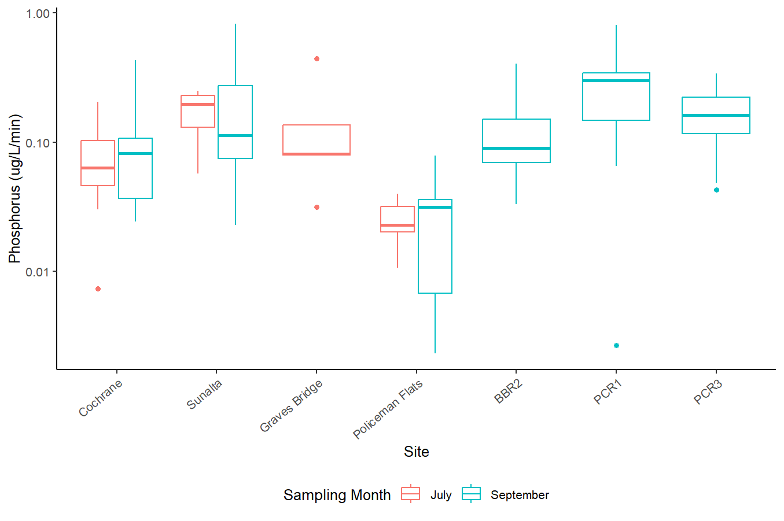

Looks like the phosphorus excretion rates between sampling months at Cochrane, Sunalta, and Policeman Flats are not much different from one another, but all sites look higher than Policeman Flats.

**Mixed Effects Model:**

Model setup:

***Dependent variable:*** log transformed phosphorus excretion rate (logPrate; to meet assumptions of linear model) measured in µg/L/minute.

***Fixed effect****:* Site as a proxy of wastewater effluent exposure. Mass (mg) because larger organisms tend to consume and excrete a greater volume of nutrients. Water temperature because temperature affects metabolic rate hence potentially the excretion rate.

***Random effect****:* Month (July or September). To account for the repeated measures design.

Because we are interested in determining the difference in excretion rate across sites (used as a proxy for municipal wastewater effluent exposure), site is a fixed effect. Because of the repeated measures design (2 timepoints) and because we don’t care as much about the difference between time points, the month is the random factor (July vs September).

The models used for model selection (using p-value and AIC method) are as follows:

**m1<-lmer(data=Nut_samples, logPrate~Mass * Site * Water_Temp + (1|Month))**

**m2<-lmer(data=Nut_samples, logPrate~Mass + Site + Water_Temp + (1|Month))**

**m3<-lmer(data=Nut_samples, logPrate~Mass + Site + (1|Month))**

*#This one is the best using AIC and p-value method*

**m4<-lmer(data=Nut_samples, logPrate~ Site + (1|Month))**

**mixedmodels=list(m1, m2, m3, m4)**

**aictab(cand.set = mixedmodels)**

Model selection based on AICc:

K AICc Delta_AICc AICcWt Cum.Wt Res.LL

**Mod3 10 279.06 0.00 0.90 0.90 -128.08**

Mod2 11 284.03 4.96 0.08 0.98 -129.25

Mod4 9 286.38 7.32 0.02 1.00 -133.02

Mod1 22 331.66 52.60 0.00 1.00 -135.92

This model identified significant differences in phosphorus excretion rate between:

|  |  |
| --- | --- |
| **Comparison** | **p-value** |
| Policeman Flats – Cochrane | 0.0348 |
| Policeman Flats - Sunalta | <0.001 |
| Policeman Flats – Graves Bridge | 0.0136 |
| Policeman Flats – BBR2 (ACWA Control) | 0.0076 |
| PCR1 (ACWA 5%) – Policeman Flats | <0.001 |
| PCR3 (ACWA 15%) – Policeman Flats | <0.001 |

**a**

**a**

**a**

**a**

**a**

**a**

**b**

Model 2: Phosphorus excretion rate, not normalized by dry mass (ug/L/min)

**General Linear Model:**

Running a multiple linear regression with the same variables, the best model was:

**lm4<-lm(data=Nut_samples, logPrate~Site+Mass)** with site and mass as predictor variables.

*This yielded the exact same results as the linear mixed effect models but with slightly different p-values. Which approach makes more sense in this case?*

**Conclusion:** Organisms from Policeman Flats have a significantly lower phosphorus excretion rate which is in opposition to the original prediction that sites downstream of municipal wastewater effluent would have organisms with greater excretion since there are usually excess nutrients from wastewater. The city of Calgary water quality monitoring data shows that Policeman Flats has the highest total phosphorus concentration from the sites sampled here, indicating that it is not phosphorus limited compared to the others. *Why might we be seeing this?* *Metals? Total solids? A shift in diet from a more terrestrial to aquatic source? Could the stable isotopes be useful here?*

Most sites have a positive correlation between excretion rate and dry mass (mg) but some sites have a negative one (Sunalta in July and PMF in September).

When sampling months are combined it looks like mostly a positive correlation btw mass and excretion at all sites (except Sunalta).

**Nitrogen – Ammonia**

Plotting nitrogen excretion rate (µg/L/minute) from July (red) vs September (blue) at each site. All data points included in figure.

Looks like there are differences in nitrogen excretion rate across sampling time points. There are 16 data points that have negative excretion so those will be removed via log transforming.

Log transformed nitrogen excretion rate across sites. (16 points removed).

Looks like in July (red), all sites are fairly equal in the nitrogen excretion rate but in September, organisms from Sunalta may have a significantly lower nitrogen excretion. Overall, it doesn’t look like a clear pattern across sites.

**Mixed Effects Model:**

The same variables as used in the phosphorus mixed model were considered for nitrogen excretion.

Models are as follows:

**NH3_m1<-lmer(data=Nut_samples, logNH3Excr~Site * Mass * Water_Temp + (1|Month))**

**NH3_m2<-lmer(data=Nut_samples, logNH3Excr~Site + Mass + Water_Temp+(1|Month))**

**NH3_m3<-lmer(data=Nut_samples, logNH3Excr~Water_Temp+Site+(1|Month))**

**NH3_m4<-lmer(data=Nut_samples, logNH3Excr~Water_Temp+(1|Month))**

**NH3_m5<-lmer(data=Nut_samples, logNH3Excr~Site+(1|Month))**

#This was the best model based on AIC

NH3mixedmodels=list(NH3_m1, NH3_m2, NH3_m3, NH3_m4, NH3_m5)

aictab(cand.set = NH3mixedmodels)

Model selection based on AICc:

K AICc Delta_AICc AICcWt Cum.Wt Res.LL

**Mod5 9 207.95 0.00 0.58 0.58 -93.50** #Only Site included as a predictor variable

Mod3 10 208.76 0.82 0.38 0.96 -92.55

Mod2 11 213.99 6.04 0.03 0.99 -93.76

Mod4 4 216.11 8.16 0.01 1.00 -103.75

Mod1 22 257.07 49.13 0.00 1.00 -96.00

This model had significant comparisons in nitrogen excretion rate between the following:

|  |  |
| --- | --- |
| **Comparison** | **p-value** |
| Sunalta - Cochrane | 0.00564 |
| PCR3 - Cochrane | 0.0108 |
| Policeman Flats - Sunalta | 0.0237 |

**\***

**\***

**\*\***

**General Linear Model:**

**NH3lm1<-lm(data=Nut_samples, logNH3Excr~Site * Mass * Water_Temp * Month)**

**NH3lm2<-lm(data=Nut_samples, logNH3Excr~Site + Mass + Water_Temp + Month)**

*#Best model using AIC*

**NH3lm3<-lm(data=Nut_samples, logNH3Excr~Site + Water_Temp + Month)**

**NH3lm4<-lm(data=Nut_samples, logNH3Excr~Site + Water_Temp)**

**linearmodels<-list(NH3lm1, NH3lm2, NH3lm3, NH3lm4)**

**aictab(cand.set = linearmodels)**

Model selection based on AICc:

K AICc Delta_AICc AICcWt Cum.Wt LL

**Mod2 11 197.48 0.00 0.59 0.59 -85.50**

#Model with site, mass, water temp, and sampling month is the best

Mod3 10 199.12 1.64 0.26 0.85 -87.73

Mod4 9 200.53 3.04 0.13 0.98 -89.79

Mod1 21 203.94 6.45 0.02 1.00 -71.54

This model had significant comparisons in nitrogen excretion rate between:

|  |  |
| --- | --- |
| **Comparison** | **p-value** |
| Sunalta - Cochrane | 0.0026 |
| PCR3 - Cochrane | 0.0139 |
| Policeman Flats - Sunalta | 0.0381 |
| PCR1 - Sunalta | 0.0176 |
| PCR3 – PCR1 | 0.0304 |

The multiple linear regression found two extra significant comparisons over the linear mixed model; however the results are not that different because the two extra comparisons were really close to being significant in the linear mixed model. Which is better in this case? How do you decide?

**\***

**\***

**\***

**\***

**\*\***

**Conclusion:** Organisms are excreting nitrogen at the same rate at most sites which does not support the original hypothesis that organisms from sites downstream of wastewater outfall would have an increased excretion rate as these sites tend to have higher nutrient influx and usually aren’t nutrient limited. Sunalta had the lowest nitrogen excretion rate indicating that it may be slightly nitrogen limited compared to the other sites, however it was not significantly lower than most sites including the 15% effluent ACWA stream (PCR3) which would have the highest effluent exposure across all sites (not supporting the hypothesis).

In the ACWA streams, both the effluent exposed streams had no significant difference compared to the control, indicating no effect of wastewater effluent on the nitrogen excretion rate. The differences may be due to other site specific characteristics besides the exposure to wastewater or organism specific differences.

Correlation test between mass normalized Phosphorus excretion rate and Nitrogen excretion rate from all sites:

**cor(Nut_samples$Excr_rate_P, Nut_samples$Excr_rate_NH3)** #0.018

Not correlated.

Most sites have a positive correlation between nitrogen excretion rate and dry mass (mg) but some sites have a negative one (Sunalta in July, PMF in September (although only 2 data points), BBR2)

When sampling months are combined all bow river sites have a positive correlation but BRR2 in the ACWA streams still does not.